
Prof. Dr. Rainer Kleber
Production und Logistics

  - Type of Paper Here

  - Seminar Title Here

Title of Paper or Thesis

My Name

Email: my.email@st.ovgu.de
Matriculation number: 123456
Semester of study: 6
Study program: IBE
Submission date: dd.mm.yyyy

Table of Contents
Table of Contents II
List of Abbreviations III
List of Symbols IV
List of Figures V
List of Tables VI
1. Introduction 1
2. Another Main Heading 1
2.1 Subheading 1
2.2 Another Subheading 2
3. Conclusions 2
Appendix 3
Bibliography 4

List of Abbreviations
EOQ Economic order quantity

List of Symbols
$d$ Demand rate [units/time unit]
$F$ Fixed cost for ordering [monetary units]
$h$ Holding cost rate [monetary units/(unit·time unit)]
$q$ Lot size [units]

List of Figures
Figure 1. A brown fox. Source: cdn.pixabay.com/photo/2016/01/05/06/01/fox-1122021_960_720.jpg 2

List of Tables
Table 1. Interesting relationships between numbers. Source: own table. 1

1. Introduction
The quick brown fox jumps over the lazy dog. The quick brown fox jumps over the lazy dog. The quick brown fox jumps over the lazy dog. The quick brown fox jumps over the lazy dog. The quick brown fox jumps over the lazy dog. The quick brown fox jumps over the lazy dog. The quick brown fox jumps over the lazy dog.

2. Another Main Heading

2.1 Subheading
The quick brown fox jumps over the lazy dog. The quick brown fox jumps over the lazy dog. The quick brown fox jumps over the lazy dog. The quick brown fox jumps over the lazy dog. The quick brown fox jumps over the lazy dog. The quick brown fox jumps over the lazy dog. The quick brown fox jumps over the lazy dog.
The following equation (1) describes the economic order quantity $q^{*}$ that depends on the demand rate $d$, the fixed cost $F$ as well as on the holding cost rate $h$:
$q^{*}=\sqrt{\frac{2∙d∙F}{h}}$ (1)
Table 1 shows some interesting fact.
Table 1. Interesting relationships between numbers. You can insert a caption choosing “Insert Caption” located in tab “References”. Choose type “Table”. Tables are numbered automatically and will appear in the autogenerated List of Tables. Source: own table.
$$X$$ | $$2⋅X$$ | $$X^{2}$$ | $$1/X$$
1 | 2 | 1 | 1
2 | 4 | 4 | ½
3 | 6 | 9 | 1/3
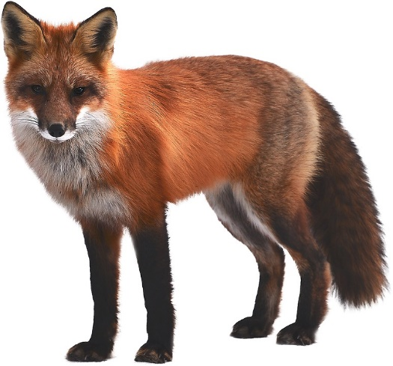
Figure 1. A brown fox. You can insert a caption per right click onto the figure and then select “Insert Caption”. Choose type “Figure”. Figures are numbered automatically and will appear in the autogenerated List of Figures. Source: cdn.pixabay.com/photo/2016/01/05/06/01/fox-1122021_960_720.jpg
Figure 1 could be interesting as well.

2.2 Another Subheading
The quick brown fox jumps over the lazy dog. The quick brown fox jumps over the lazy dog. The quick brown fox jumps over the lazy dog. The quick brown fox jumps over the lazy dog. The quick brown fox jumps over the lazy dog. The quick brown fox jumps over the lazy dog. The quick brown fox jumps over the lazy dog.

3. Conclusions
The quick brown fox jumps over the lazy dog. The quick brown fox jumps over the lazy dog. The quick brown fox jumps over the lazy dog. The quick brown fox jumps over the lazy dog. The quick brown fox jumps over the lazy dog. The quick brown fox jumps over the lazy dog. The quick brown fox jumps over the lazy dog.

Appendix
The quick brown fox jumps over the lazy dog. The quick brown fox jumps over the lazy dog. The quick brown fox jumps over the lazy dog. The quick brown fox jumps over the lazy dog. The quick brown fox jumps over the lazy dog. The quick brown fox jumps over the lazy dog. The quick brown fox jumps over the lazy dog.

Bibliography

Confirmation
Hiermit versichere ich, dass ich die Arbeit selbstständig und ohne die Benutzung anderer als der angegebenen Hilfsmittel angefertigt habe und alle Stellen, die wörtlich oder sinngemäß aus veröffentlichten oder unveröffentlichten Schriften entnommen wurden, als solche kenntlich gemacht habe. Weiterhin erkläre ich, dass die vorliegende Arbeit nicht, auch nicht auszugsweise, bereits für eine andere Prüfung angefertigt wurde.
I declare that I completed this thesis independently and using only the sources listed. All materials used, from published as well as unpublished sources, whether directly quoted or paraphrased, are duly reported. Furthermore, I declare that neither this thesis in full nor any part of it was for any other degree-seeking purpose.

Signature Place, Date

